ASSESSMENT TOOL 1 – Coding Challenge
Computer Networks (CO4_AT1)
CHALLENGE 1: UDP ANALYSIS
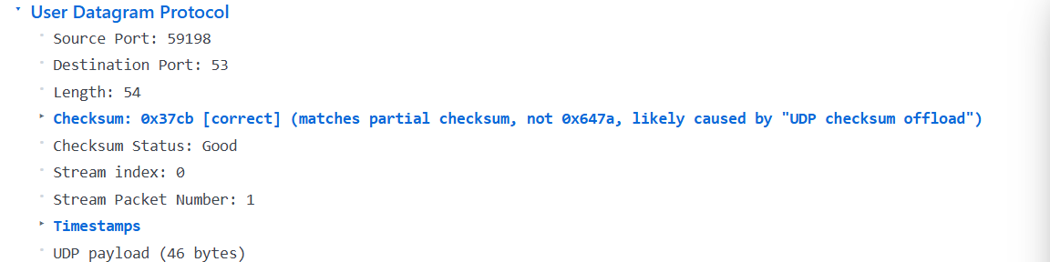
DESTINATION PORT53 IS THE WELL KNOWN PORT FOR THE DOMAIN NAME SYSTEM (DNS) SERVICE [ANSWER]

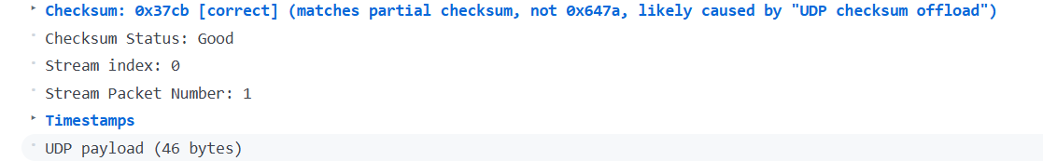
UDP fields (bytes 38-41)
- Length: 54 bytes (0x0036) – the size of the UDP header plus its payload.
- Checksum: 0x37CB – shown as “correct” (partial checksum due to offload).
Sequence / acknowledgement numbers:
UDP does not contain a sequence number or an acknowledgement number. This reflects UDP’s design as a connection-less, best-effort transport: it provides only port-based multiplexing and a checksum, leaving ordering, reliability, and flow control to the application layer.
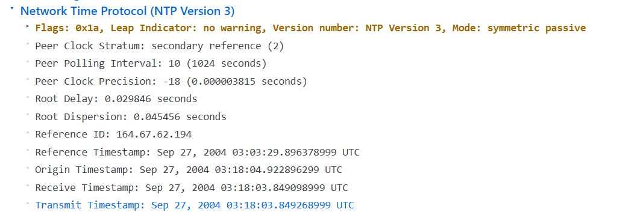
UDP header comparison
Field | Size (bytes) | NTP packet (shown) | Typical DNS packet
Source Port | 2 | 0x007B (123) | varies (e.g., 0xC350 = 50000)
Destination Port | 2 | 0x007B (123) | 0x0035 (53)
Length | 2 | 0x0038 (56) | length of DNS message + 8
Checksum | 2 | 0x70E1 (valid) | checksum (optional, may be 0)
- Field sizes are identical: every UDP header is exactly 8 bytes, regardless of the application (NTP, DNS, etc.). Only the values differ (ports, length, checksum).
Why UDP works for both DNS and NTP
- Connection-less & low overhead – No three-way handshake; a single packet carries the request (DNS query or NTP request) and the response fits in one datagram.
- Small, time-critical messages – DNS queries/responses and NTP timestamps are short enough to fit well within the typical MTU, so retransmission isn’t usually required.
- Tolerance for occasional loss – A lost DNS query can be retried by the client; a missed NTP poll is simply ignored until the next poll.
======================================================================
======================================================================Challenge Set 2: TCP Analysis:
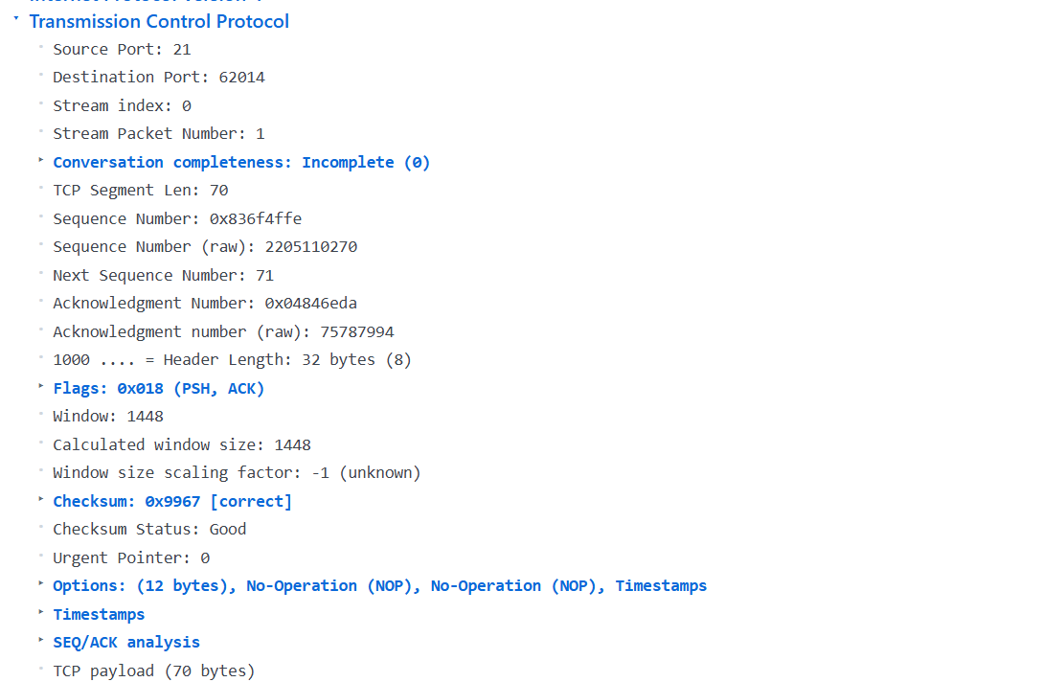
TCP header (expanded)
Field | Value
Source Port | 21 (0x0015)
Destination Port | 62014 (0xF23E)
Sequence Number | 2 205 110 270 (0x836F4FFE)
Acknowledgment Number | 75 787 994 (0x04846EDA)
Flags | PSH and ACK are set (0x018). No SYN, FIN, RST, URG, ECE, CWR.
4-tuple (socket identifier)
- Source IP: 192.168.1.231
- Source Port: 21
- Destination IP: 192.168.1.182
- Destination Port: 62014
How it enables demultiplexing
When a TCP segment is received, the operating system looks at these four fields. It searches its list of open TCP sockets for an entry whose 4-tuple matches exactly. The matching socket is then handed the segment, allowing the OS to keep separate streams of data for each concurrent connection. Because the combination of source address + source port + destination address + destination port is unique for every active TCP connection, this tuple provides the precise key for TCP demultiplexing.

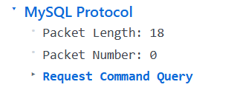
TCP ports in the MySQL sample
- Source port: 56162
- Destination port: 3306 (standard MySQL service)
Typical FTP sample ports
- Control connection: port 21 (server) – client uses an arbitrary high-numbered source port.
- Data connection (active mode): port 20 (server) – client again uses a high-numbered source port.
Destination ports – same or different?
They are different. The MySQL packet is addressed to port 3306, while an FTP control packet would be addressed to port 21 (or 20 for data).
How the OS knows which application receives the packet (demultiplexing)
- Protocol field – The IP header indicates the next-level protocol (TCP = 6).
- Port numbers – The TCP header carries a 16-bit source and destination port.
- Socket table – The OS maintains a table of sockets, each identified by the tuple (protocol, local IP, local port, remote IP, remote port) (or a subset for listening sockets).
- Lookup – When a packet arrives, the kernel looks up the destination port (and protocol) in that table.
- Delivery – If a socket is bound to that port (e.g., a MySQL server listening on 3306), the packet is handed to that application; otherwise it is dropped or an error (e.g., RST) is sent.
Thus, the combination of the protocol identifier and the destination port allows the operating system to demultiplex incoming traffic to the correct process.
======================================================================
Challenge Set 3: TCP vs UDP Comparison:
Header size
Protocol | Header length (bytes)
DNS (UDP) | UDP header = 8 B (plus 12 B DNS header = 20 B total)
FTP (TCP) | TCP header = 32 B (includes 12 B options) + IP = 20 B → 52 B total
The FTP packet therefore has the larger header.
Reliability features
- TCP (FTP) shows sequence number = 0x836F4FFE, acknowledgment number = 0x04846EDA, flags = PSH + ACK, window = 0x05A8, and checksum. These fields provide ordering, loss detection, flow control and retransmission – the classic reliability mechanisms.
- UDP (DNS) has no sequence/ack fields, no flags, and a fixed 8-byte header, so it provides no reliability.
Connection-oriented vs. connection-less
- FTP/TCP is connection-oriented: the presence of SYN/ACK (not shown in this segment but part of the TCP state machine) and the use of sequence/ack numbers proves a established connection.
- DNS/UDP is connection-less: UDP carries only source/destination ports and length/checksum, with no handshake or state, confirming it is stateless.
Evidence from the dumps
- DNS segment starts with 08 00 (Ethernet type IPv4) → IP → 11 (protocol = UDP) → UDP header 00 35 00 36 … (no seq/ack).
- FTP segment starts with 08 00 → IP → 06 (protocol = TCP) → TCP header 00 15 F2 3E … 83 6F 4F FE … 04 84 6E DA … 80 18 … (seq, ack, flags, window).
- TCP fields that implement reliability and flow-control
Field | Value (hex) | What it does
Sequence Number | 83 6F 4F FE (2205110270) | Orders bytes in the stream; receiver uses it to detect gaps and request retransmission.
Acknowledgment Number | 04 84 6E DA (75787994) | Confirms receipt of all bytes up to this number (cumulative ACK).
Flags | 0x18 → ACK + PSH | ACK signals the acknowledgment number is valid; PSH tells the receiver to push the data to the application immediately.
Window Size | 05 A8 (1448) | Advertises how many bytes the sender is allowed to transmit before waiting for further ACKs – the core flow-control mechanism.
Checksum | 99 67 | Verifies integrity of the TCP segment (covers header + data).
TCP Options – Timestamps | 08 0A 3C F6 A9 AA 1E 8D 47 F6 (TSval = 1022798250, TSecr = 512575478) | Used for RTT measurement and PAWS; helps avoid old duplicate segments, aiding reliability.
- These fields together give TCP its reliable, ordered delivery and congestion/flow-control capabilities.

=======================================

Challenge Set 4: Modern Transport:
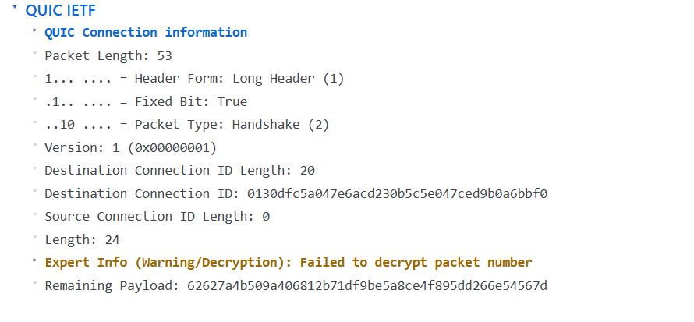
Underlying transport protocol: UDP (the packet shows a UDP header before the QUIC payload).
Destination port: 443 (hex 01 BB).
Key differences between QUIC and classic TCP (even though QUIC runs over UDP):
- Built-in encryption: QUIC always uses TLS 1.3, so all payloads are encrypted; TCP is plaintext unless TLS is added on top.
- Connection migration: QUIC connections can survive changes in IP address or network interface because the transport state is in the encrypted payload, not the IP/UDP headers.
- 0-RTT/1-RTT handshake: QUIC can complete the cryptographic handshake in the first packet (or even with 0-RTT data), reducing connection-setup latency compared with TCP’s three-way handshake plus TLS handshake.
- Stream multiplexing without head-of-line blocking: Multiple independent streams share a single QUIC connection; loss on one stream does not stall others, unlike TCP where packet loss blocks the entire connection.
- User-space implementation: QUIC runs in user space (over UDP), allowing faster iteration and updates without kernel changes, whereas TCP is typically kernel-implemented.
=========================================

NAME: P.V. GIRIDHAR
REG NO: 1972260022

